Project Design Phase
Solution Architecture

Date | 28 June 2026
Team ID
Project Name | ONLINE COMPLAINT REGISTRATION
Maximum Marks | 4 Marks

Solution Architecture:
Solution architecture is a complex process – with many sub-processes – that bridges the gap between business problems and technology solutions. Its goals are to:
- Find the best tech solution to solve existing business problems.
- Describe the structure, characteristics, behavior, and other aspects of the software to project stakeholders.
- Define features, development phases, and solution requirements.
- Provide specifications according to which the solution is defined, managed, and delivered.

Example - Solution Architecture Diagram:


Figure 1: Architecture and data flow of the voice patient diary sample application
Reference: https://aws.amazon.com/blogs/industries/voice-applications-in-clinical-research-powered-by-ai-on-aws-part-1-architecture-and-design-considerations/

ResolveHub - Solution Architecture Diagram
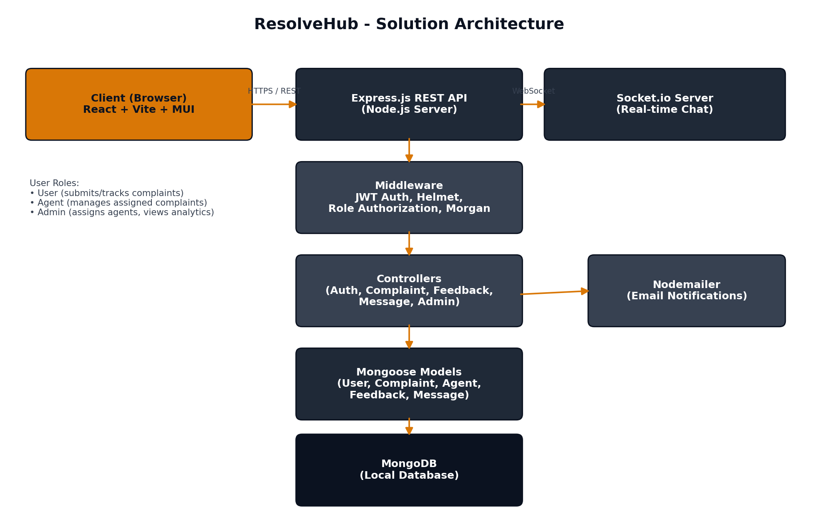

Architecture Description:
• Client Layer: A React (Vite) single-page application styled with Material UI (MUI). It renders three role-specific dashboards (User, Agent, Admin) and communicates with the backend via REST (Axios) and a persistent Socket.io connection for live chat.
• API Layer: An Express.js server exposes REST endpoints under /api/auth, /api/complaints, /api/feedback, /api/messages, and /api/admin. Helmet and CORS secure HTTP headers/origins, and Morgan logs all requests.
• Middleware Layer: JWT-based authentication verifies the bearer token on protected routes, and role-authorization middleware restricts each route to the appropriate role (USER, AGENT, ADMIN).
• Controller Layer: Controllers contain the business logic for authentication, complaint lifecycle management, agent assignment, feedback/rating, messaging, and admin analytics aggregation.
• Data Layer: Mongoose models (User, Agent, Complaint, Feedback, Message) map to collections in a local MongoDB instance, with relationships (e.g., a Complaint references its User and assigned Agent).
• Real-time Layer: A Socket.io server, authenticated via the same JWT, allows a user and their assigned agent to join a complaint-specific room and exchange messages instantly without polling.
• Notification Layer: Nodemailer is integrated for sending email notifications (e.g., on complaint assignment or resolution) as part of the controller logic.

